Unity Developer Assignment

Please play few of our driving game like Driving academy, Parking Frenzy 3D available on both Google play store and itunes.

UI Assignment
Go to the Settings screen in our game. (Usually accessed from a Gear icon on the chapter or main screens) Here’s what the screen looks like in one of our games :

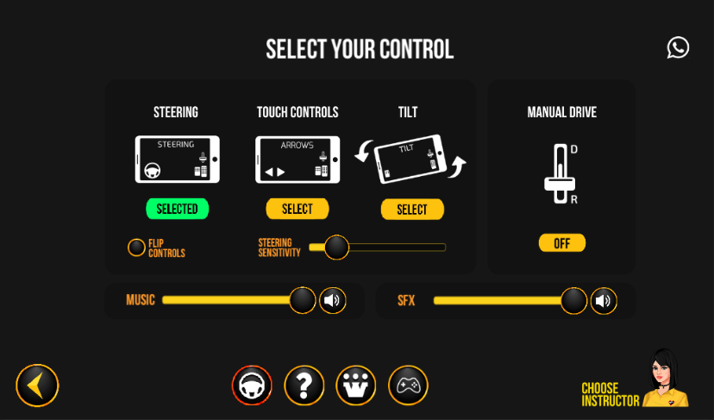

UI Programming Tasks
- Replicate the screen shown above in a new Unity project with the assets provided. Do make sure the UI elements do not get displaced from original positions when the screen resolutions are changed.
- Add visual cues when the Steering, Touch Controls, Tilt and Flip Controls buttons are used. For example, in the screenshot above, the color of the button is changed to green when it’s selected.
- At the bottom of the screen are 2 buttons, one with a “?” icon (Help) and another with “W” icon(Games2Win logo).
  - Write functionality for the Help button, such that it opens a new unity scene on top of the current scene. This scene can contain a dummy text, but must have a back button. Pressing the back button returns you to the Settings screen.
  - On pressing the button with the W logo, the user should be taken to the Games2Win website (www.games2win.com).
- Make a new Unity scene that has a swipe based menu of 10 dummy images; as you swipe the screen left or right, the image shown changes. Each image will have a name of the image, and a description of the image. This data for all the images should be in an external file (e.g. json, xml, csv,). This Scene should open when the user taps on the Steering button at the bottom.
- Make the sliders of sensitivity, music and vfx interactive. Write a functionality such as the user can keep the slider to whichever value they want and when the project is quit and restarted or the scene is changed and returned to the given scene, the user’s values should reflect back.

You can download the UI assets from below link:-
https://drive.google.com/drive/folders/0B-1nwF8XeYtgbkk5Q3JHbTMzRW8?usp=sharing

Besides your programming and UI skills we want to check how you maintain naming conventions, folder structures and hierarchy in editor.

